



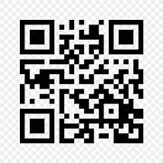 ADMISSION OPEN 2024-2025

REGISTER NOW LIMITED SEATS

CONTACT NO.8588853380

LITERACY INDIA COMMUNITY COLLEGE

JGJHGJ

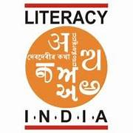

PROGAMME OFFERED

* ROBOTICS/TINKERING
* COMPUTER HARDWARE
* COOKING/HOSPITALITY
* BEAUTY AND WELLNESS
* STITCHING AND CUTTING
* ELECTRICAL TROUBLESHOOTINGE
* TWO WHEELWE REPAIRING
* MOBILE JOURNALISM
* COMPUTER SCIENCE
* CALL CENTER /BPO
* DATA DIGITIZATION
* BANKING



WWWWWWWWWWWWWWW

WWWWWWW

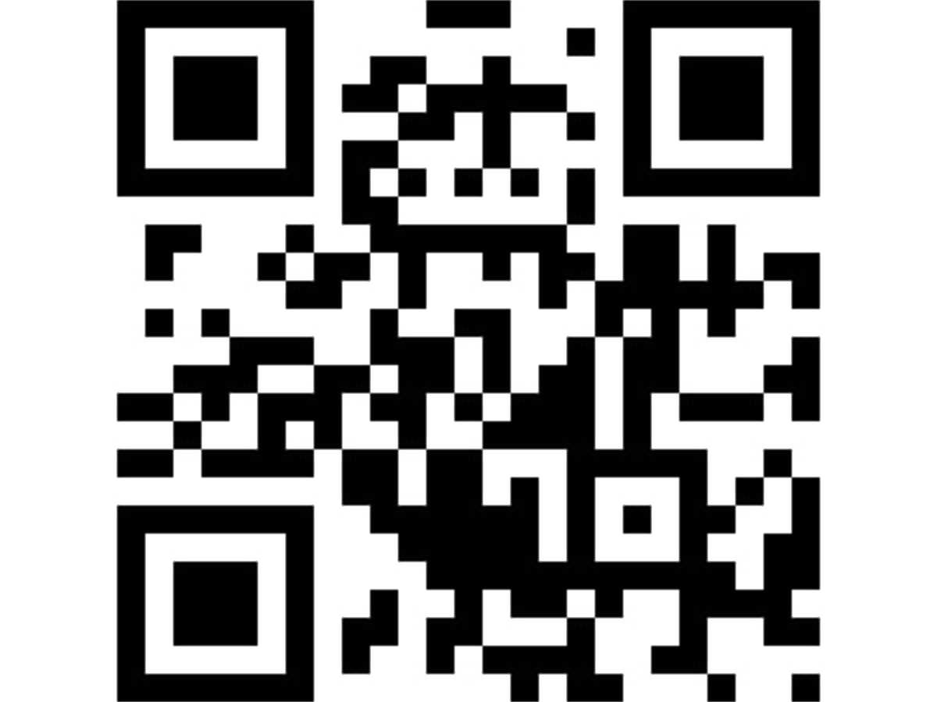

W

W

WW